Chapter 11, Solution 69.

Refer to the circuit shown in Fig. 11.88.
- What is the power factor?
- What is the average power dissipated?
- What is the value of the capacitance that will give a unity power factor when connected to the load?

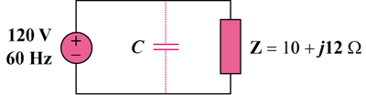
120 Vrms

Figure 11.88
For Prob. 11.69.

Solution

- Given that
= 0.6402 (lagging)

The average power absorbed

- For unity power factor, , which implies that the reactive power due to the capacitor is
But

